

Department of Computer Science and Engineering
“Support System Site”

Brand name: “Support Hero”
Software Requirements Specification
Version 1.0
11.08.25

Course Title : Software Engineering and System Analysis Lab
Course Code : CSE0613226

Submitted to : Sadia Jahan
Assistant Professor, Department of CSE

Submitted by : 1. Partho Kumar Ray Amit (070)
2. Md. Ashraful Haque Zani (075)
3. Gaus Saraf Murady (088)
4. Md. Jubair Ahammed (112)

Submission Date : 11.08.2025

Support Hero

Table of Contents
1. INTRODUCTION ............................................................................................... 3
1.1 Purpose
1.2 Scope
1.3 Definitions, Acronyms, and Abbreviations
1.4 References
1.5 Overview
2. GENERAL DESCRIPTION .................................................................................. 4
2.1 Product Perspective
2.2 Product Functions
2.3 User Characteristics
2.4 General Constraints
2.5 Assumptions and Dependencies
4. ANALYSIS MODELS ......................................................................................... 6
4.1 Sequence Diagrams
4.2 Data Flow Diagrams (DFD)
4.3 State-Transition Diagrams (STD)
5. CHANGE MANAGEMENT PROCESS ................................................................. 7
A. APPENDICES .................................................................................................. 7
A.1 Appendix 1
A.2 Appendix 2
A.3 Appendix 3

1. INTRODUCTION

1.1 Purpose
This document outlines the software requirements specification for the “Support System Site” or, "Support Hero" system — a digital platform that connects individuals who need help (requesters) with volunteers who can offer support across multiple domains, including cleanliness, minor services, delivery assistance, and more.

1.2 Scope
(Contents of this section is defined by the user roles in Section 2.3 and the product functions in Section 2.2)
1.2.1 Visitors to submit feedback and join project
This project lets visitors to explore our activities and achievements before deciding whether they should join as well. Visitors are encouraged to share their feedback in the Feedback section, that will be received by our moderation team.

1.2.2 Supporters to request tasks and fund them
Supporters are people who will keep the project running. Supporters actively support the Volunteers by requesting services from them. They can also add bounty with their request signifying urgency in that task. Examples of such people include the upper middleclass, Rich, Government Officials etc.

1.2.3 Volunteers to browse and accept requests
Volunteers are the core workforce of this project. We address our Volunteers as “Heros” and they are to respond to the call-to-help by our Supporters. Volunteers are compensated for their efforts based on their individual contributions.

1.2.4 Admins to manage users and content
Admins work behind the scenes and keep the system running. All Feedback are sent to the admin panel for reviewing. Requests from the supporters are also reviewed by the admins before getting listed at the Volunteer’s tasks list. It also includes a recognition system, chatbot support, and real-time request tracking for transparency.
1.3 Definitions, Acronyms, and Abbreviations
- Supporter: User who donates or requests services
- Volunteer: Individual who fulfills requests
- DB: Database
- DFD: Data Flow Diagram
- STD: State Transition Diagram
- UI: User Interface
- Bounty: Incentive or reward attached to a task

1.4 References
- https://www.bdclean.org/ is a similar project to “Support Hero”
- https://theoceancleanup.com/ they clean parts of the ocean and prevent garbage from flowing out in the ocean from rivers.

1.5 Overview
This SRS summarizes the system’s intent, major components, target users, and technical constraints. It serves as a guide for developers, designers, and stakeholders, with detailed models and descriptions of system behavior.

2. GENERAL DESCRIPTION

2.1 Product Perspective
Support Hero is a web-based application that serves as an intermediary platform for community support. Unlike traditional systems focused only on waste management, this system supports various help-driven services such as minor tasks, community outreach, and digital assistance — all coordinated via a volunteer network.

2.2 Product Functions
- Hero-style landing page
- Separate login for Supporters, Volunteers, and Admin
- Request creation and feedback forms
- Volunteer dashboard for task viewing and response
- Reward system with bounties and donation tiers
- AI chatbot for awareness and guidance
- Dashboard showcasing achievements, cleanups, and contributions

2.3 User Characteristics
2.3.1 Visitors
- Profile: Curious users or potential future supporters and volunteers.
- System Capabilities: Can explore the project's activities and achievements. They are encouraged to submit feedback which is received by the moderation team.
2.3.2 Supporters
- Profile: Individuals from well-off backgrounds such as the upper-middle class, the rich, or government officials. They are essential to keeping the project running.
- System Capabilities: Actively support volunteers by requesting services from them. They can add a monetary bounty to their requests to signify urgency.
2.3.3 Volunteers (Heroes)
- Profile: The core workforce for the project, referred to as "Heroes". They may be students, job seekers, or individuals from underprivileged groups.
- System Capabilities: Respond to help requests from Supporters. They can browse and accept these requests from a task list and are compensated for their work based on their contributions.
2.3.4 Admins
- Profile: Backend operators responsible for platform moderation and analytics.
- System Capabilities: Work behind the scenes to keep the system running. They manage users and content, review all visitor feedback, and approve supporter requests before they appear on the volunteer task list.

2.4 General Constraints
- Must support mobile-friendly usage
- NoSQL compatibility needed for dynamic database like Firebase
- Reward/bounty system must comply with legal regulations
- Clean and intuitive UX for low-tech users

2.5 Assumptions and Dependencies
- Firebase will be used for deployment and hosting in the live version
- Volunteers will be driven by incentives and social good
- Supporters will act honestly and responsibly
- System will eventually seek government or NGO partnerships

4. ANALYSIS MODELS

4.1 Sequence Diagrams

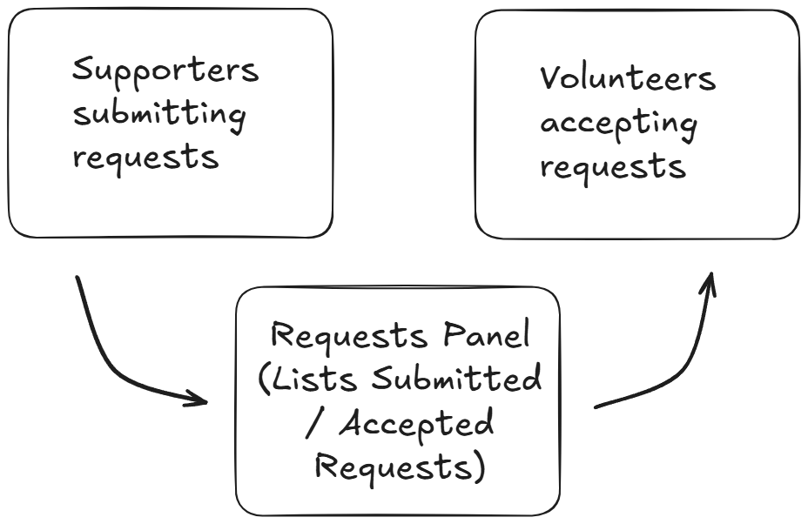

4.2 Data Flow Diagrams (DFD)
Main flows include:
- Visitor → Submit Request → Feedback/Request DB
- Volunteer → View Request → Submit Response → Volunteer DB
- Supporter → Donate → Update Achievement DB
- Admin → Monitor all 3 databases

4.3 State-Transition Diagrams (STD)
Sample transitions:
- Visitor → Registered Supporter/Volunteer
- Request Status: New → Viewed → Accepted → Completed
- Volunteer Status: Idle → Engaged → Completed Task → Rated

5. CHANGE MANAGEMENT PROCESS
Changes are reviewed bi-weekly. Team leaders will maintain version control and update the shared SRS file upon changes in:
- Technology stack
- Functional modules
- Data structure or UI layouts
- Feedback is managed through regular team meetings

A. APPENDICES

A.1 Appendix 1
- Frontend: HTML, CSS, JavaScript
- Backend: PHP or Python
- Database: Firebase / MongoDB (NoSQL) Atlas / SQL
- UI Tools: Canva, Figma, Draw.io

A.2 Appendix 2
- Marketing Motto:
“Support calls for help, and the Heroes answer.”
- Volunteers are titled “Heroes” and publicly appreciated via awards, rankings, and donation-backed incentives
- AI Assistant helps spread awareness on civic duties, ethics, environmental care, and social participation

A.3 Appendix 3
- Market Research done using Grok AI’s “DeepSearch” feature:
"Support Hero" has the potential to address critical social issues in Bangladesh, given high unemployment and homelessness, with a demand for community services. While facing competition from established NGOs and government programs, it can differentiate through its voluntary service model and digital platform. Challenges in monetization and scaling exist, but partnerships and mobile technology can mitigate these. By tailoring to local contexts and building a strong brand, "Support Hero" can achieve significant social impact and positive public reception, positioning itself as a scalable solution for future global expansion.
- Future implementations:
  - Requests behind paywall:
Supporters need to pay a minimum of 20tk per request. This is to ensure proper revenue flow and signify the importance of the time taken for making the request. This is also to ensure that people do not end up spamming free requests.
  - Cleanup Tutorials:
For basic cleanups, people shouldn’t have to rely on 3rd party organizations to come to their aid. For this, we want to introduce easy and standard methodologies for the cleanup procedures we will be following ourselves.

